**Ranking Based on the paper ‘Learning to Rank Short Text Pairs with Convolutional Deep Neural Networks’**

**A) CNN Architecture**

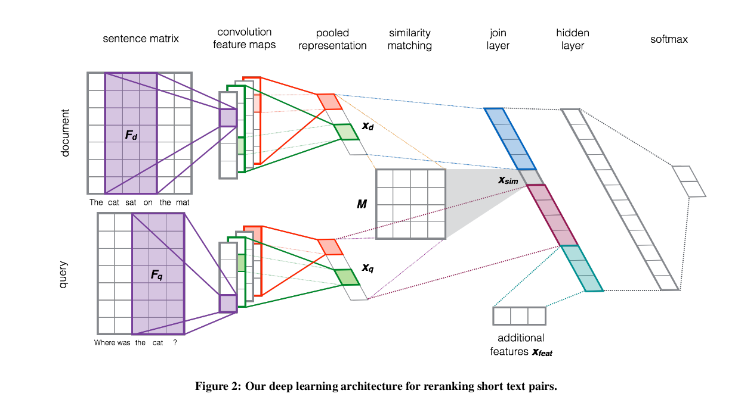

**1) Entity(document) and Query (Type) matrix:**

The input to our sentence model is a sentence s treated as a se-

quence of words: [w 1 , .., w |s| ]. For entity, it will be the context words in order of their positions. Where

Words are represented by distributional vectors w ∈ R^d looked up in a word embeddings matrix W ∈ R^d×|V |. For each input sentence s we build a sentence matrix S ∈ R d×|s| ,where each column i represents a word embedding w i at the corresponding position i in a sentence

**2) Convolution:** [Same as paper]

**3) Activation:** [Same as paper]

**4) Pooling:** [Same as paper]

Till here we will get the representation of type and entity

**5) Matching Type and Entity**

Given the output of our sentence ConvNets for processing queries and documents, their resulting vector representations x q and x d , can be used to compute a query-document similarity score.

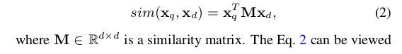

**Output Layer:** Last layers will be the probability distribution over labels.

**B) Non-linguistic features**

Entity Salience Task could be used as non linguistic features

**1. A New Entity Salience Task with Millions of Training Examples:**

i) Index of the sentence in which the first mention of the entity appears.

ii) Number of times the head word of the entity’s first mention appears.

iii) Number of mentions of that entity.

**Entity centrality:** All the features described above use only information available within the document. But articles are written with the assumption that the reader knows something about at least some of the entities involved. An entity may be mentioned just once but may be closely related to other entitites.

**Entity Centrality using Weighted page rank** as a measture. Where a directed edge between E1 -> E2 represents P(E2|E1), the probability of observing E2 in a document given that we have observed E1. We estimate P (E 2 |E 1 ) by counting the number of training documents in which E 1 and E 2 co-occur

and normalizing by the number of training documents in which E1 occurs.

The nodes’ initial PageRank values act as a prior, where the uniform distribution, used in the classic PageRank algorithm, indicates a lack of prior knowledge. Since we have some prior signal about salience, we initialize the node values to the normalized mention counts of the entities in

the document. We use a damping factor d, allowing random jumps between nodes with probability

1 − d, with the standard value d = 0.85.

**2. Understanding document aboutness-Identifying Salient Entities**

i) tf.idf of entity in D.

ii) length of D

iii) Norm frequency of entity

**3. SEL: a Unified Algorithm for Entity Linking and Saliency Detection**

